A Minor Project Proposal Report on

**Smart Waste Management System**

Submitted in Partial Fulfillment of the Requirements for the Degree of

**Bachelor’s Of Engineering In Computer Engineering** under

**Pokhara University**

Submitted by:

**Ashesh Shrestha, 161310**

**Wachaspati Arya, 161340**

**Alaka Shrestha, 161305**

**Sweta Singh, 161338**

Submitted to:

**Dr. Roshan Chitrakar**

Date:

8- August -2019



# Abstract

With the increasing population and industrialization of nations throughout the globe, waste has become a great concern for all of us. Over years, researchers figured that only waste management is not enough for its proper treatment and disposal techniques to preserve our environment and keeping it clean in this era of globalization. With the help of technology research we have introduce “*Smart Waste Management System*” and initiatives that ensures reduced amount of time and energy required to provide waste management services. In the present day scenario, many times we see that the garbage bins or Dust bin are placed at public places in the cities are overflowing due to increase in the waste every day. It creates unhygienic condition for the people and creates bad smell around the surroundings this leads in spreading some deadly diseases & human illness, to avoid such a situation we are planning to design “*Smart Waste Management System*”. In this proposed System there are multiple dustbins located throughout the city these dustbins are provided with low cost embedded device which helps in tracking the level of the garbage bins and an unique ID will be provided for every dustbin in the city so that it is easy to identify which garbage bin is full. When the level reaches the threshold limit, the device will transmit the level along with the unique ID provided. These details can be accessed by the concern authorities from their place with the help of Internet and an immediate action can be made to clean the dustbins

*Keywords:- Smart, Dustbin, Waste, Unique Id, Tracking, Authorities etc.*

Contents

Abstract i

1. Problem Statement 2

2. Objective 2

3. Significance of the study 2

4. Scope and Limitation 3

4.1. Scope 3

4.2. Limitations 3

5. Literature Review 4

5.1. Fohor Malai 4

5.2. Smartbin 5

5.3. SENSONEO(Manage Waste Smarter) 5

6. Methodology 6

6.1. Software Development Process: 6

6.2. Software Interface: 7

6.3. Front end Technologies: 8

6.4. Back end Technologies: 8

6.5. Project Management Tools: 8

6.6. Project Design Tools: 9

6.7. Hardware Interface: 9

7. Proposed Output 14

8. Project Task and Time Schedule 14

9. Bibliography 15

# Problem Statement

A big challenge in the urban cities is solid waste management. The garbage collecting authority in traditional waste management system doesn’t know about the level of garbage in dustbin, if the dust bins gets full by garbage then it gets overflowed as well as spelled out from the dustbin leading to unhygienic condition in cities. People throw garbage on that dustbin which is already overflowed. Sometimes due to unclean garbage bins bad smell arises also toxic and unhygienic gases are produced which is way to support to the air pollution and to some harmful diseases which are easily spreadable. It is very bad look of the city. Use of traditional system result in inefficient and time and money spending system.

# Objective

* The proposed system would be able to automate the solid waste monitoring process and management of the overall collection process using IOT (Internet of Things).
* The Proposed system consist of main subsystems namely Smart Trash System(STS) and Smart Monitoring and Controlling Hut(SMCH).
* In the proposed system, whenever the waste bin gets filled this is acknowledged by placing the circuit at the waste bin, which transmits it to the receiver at the desired place in the area or spot.
* In the proposed system, the received signal indicates the waste bin status at the monitoring and controlling system.
* In the proposed system, it would be able to configure the smart(shortest) route for collecting the garbage from the container.

# Significance of the study

With the web application, the administrator will be able to search for dustbins. The result will be based on the criteria the user inputs. There are several search criteria and it will be possible for the administrator of the system to manage the options for those criteria that have that.  
The result of the search will be viewed either in a list view or in a map view, depending on what criteria included in the search. The list view will have one list item for each dustbin matching the search criteria and show a small part of the dustbin information so the user can identify the dustbin. The administrator will be able to either select a dustbin as target destination or get information how to get there, or view the information of a specific dustbin.  
The web portal will provide functionality to manage the system and the dustbin information. It will also provide information about the system

# Scope and Limitation

* 1. Scope:

The scope of the proposed project is to maintain and monitor the solid waste of the town by the help of website dash board and also help to track the waste level of the city. And also provide the activeness of Waste management workers.

* This project helps to monitor the level of solid waste remotely and help to notify the worker for instance of waste level which provide greater accessibility to the dustbin.
* It provides location of dustbin to the user which are recorded in the database.
* It provides smart route for the garbage collector van which leads to reduction of fuel consuming and effective work.
* Provide work tracking platform for the workers.
* This project helps to maintain our city clean and minimize the pollution.

## Limitations

* Dustbin requires Wi-Fi network to upload the data to database. So Internet facility is required for each and every dustbin.
* Sometimes garbage indicator may indicate wrong value due to linear reading of ultrasonic sensor.
* Durability of the project is low on the hardware side.

# Literature Review

There are different company and individual team which are contributing in the similar waste management project. Where some of the project has more functionality and some of the project has more limitation. After some research we found some similar task project and website which provide similar feature equipment.

## Fohor Malai

FoharMalai is a Startup Based on Waste management & integrated environmental solutions in Nepal. We have invested in developing waste solutions for a changing world. Today, this includes not just disposal and recycling, but personal counseling to help customers achieve their green goals, including zero waste.

Fohor Malai recover the energy from the waste, called WTE(waste to energy).With the sensor based network of recycling facilities, our entire business can adapt to meet the needs of every distinct customer segment. As Startup, our motto is to maximize resource value while minimizing impact in order to further both economic and environmental sustainability for all human.

"From everyday collection, to environmental protection, think green. Think Waste Management."

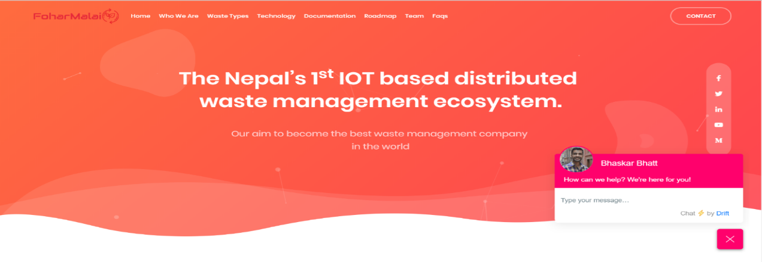

*Fig(1) : Fohor Malai Website*

## Smartbin

SmartBin have established themselves as the leader of Intelligent Remote Monitoring Systems for the waste & recycling sectors. With over 100 clients across the globe, that include both private and public collectors of waste and recyclables and distributors of fresh oil and lubricants, SmartBin have the solution, expertise, and experience to optimize any manner of collection or distribution operation. In June 2016 SmartBin was acquired by OnePlus Systems Inc., a portfolio company of Parker Gale, LP, and the world leader of Intelligent Monitoring for the waste compactor industry.

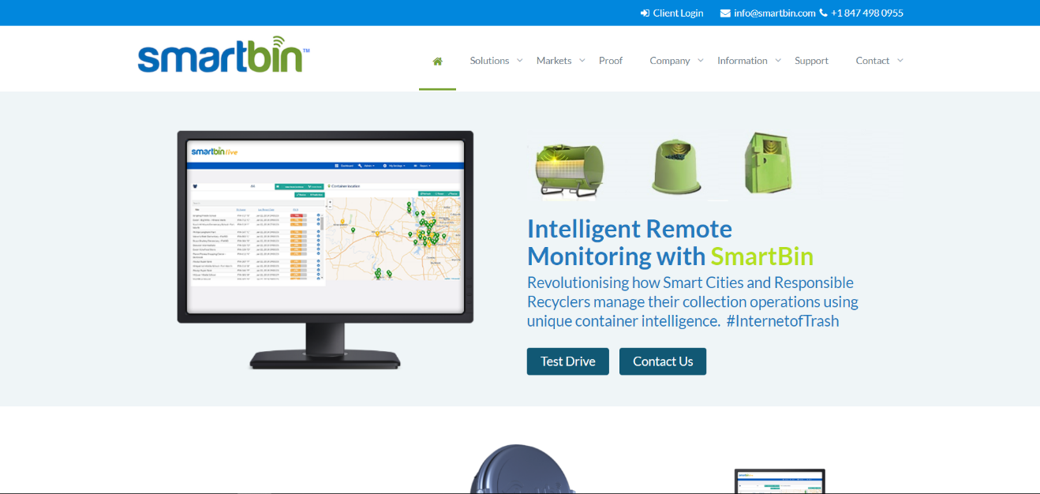

*Fig(2):Smartbin website*

## SENSONEO(Manage Waste Smarter)

Sensoneo is a global enterprise-grade smart waste management solution provider that enables cities and businesses to manage their waste cost-efficiently, be more environmentally responsible and improve the well-being of people.

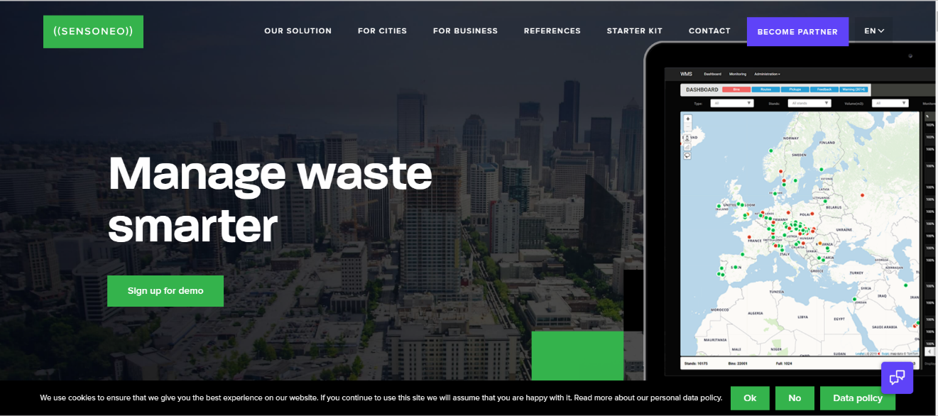

*Fig(3): Sensoneo website*

# Methodology

## Software Development Process:

The framework we propose in development of this software is “incremental model”, i.e. a method for software development where the product is designed, implemented, and tested incrementally. This model combines the elements of waterfall model with iterative philosophy of prototyping i.e. multiple development cycles take place here, making the life cycle a multi-waterfall cycle. In Incremental Model the whole requirement is divided into various builds.

When an incremental model is used, the first increment is often a core product. That is, basic requirements are addressed, but many supplementary features (some known, others unknown) remain undelivered. The core product is used by the customer (or undergoes detailed review). As a result of use and/or evaluation, a plan is developed for the next increment. The plan addresses the modification of the core product to better meet the needs of the customer and the delivery of additional features and functionality. This process is repeated following the delivery of each increment, until the complete product is produced.

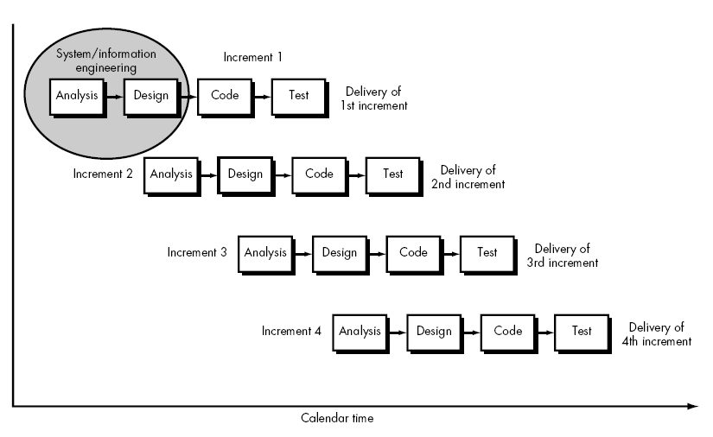

Figure 1: Incremental Model

## Software Interface:

* + 1. **Arduino IDE:**

The open-source Arduino Software (IDE) makes it easy to write code and upload it to the board. It runs on Windows, Mac OS X, and Linux. The environment is written in Java and based on Processing and other open-source software. This software can be used with any Arduino board. It contains a text editor for writing code, a message area, a text console, a toolbar with buttons for common functions and a series of menus.

* + 1. **WebServer:**  
       A Web server is a program that uses Hypertext Transfer Protocol to serve the files that form Web pages to users, in response to their requests, which are forwarded by their computers’ HTTP clients. Dedicated computers and appliances may be referred to as Web servers as well.
  1. Front end Technologies:
     1. **HTML5:**  
        HTML5 is a markup language used for structuring and presenting content on the World Wide Web. It is the latest and most enhanced version of HTML.
     2. **CSS3:**  
        Cascading Style Sheets (CSS) is a style sheet language used for describing the look and formatting of a document written in a markup language.CSS3 is a latest standard of CSS.
     3. **Javascript**:

JavaScript is a full-fledged dynamic programming language that, when applied to an HTML document, can provide dynamic interactivity on websites.

* + 1. **JQuery:**  
       JQuery is a cross-platform JavaScript library designed to simplify the client-side scripting of HTML. JQuery is the most popular JavaScript library in use today.
  1. Back end Technologies:
     1. **Django:**  
        The project is planned to make using Django which is a python web-based framework.
     2. **MySql:**  
        MySQL is an open-source relational database management system (RDBMS).It is very fast, reliable, and easy to use.

## Project Management Tools:

* + 1. **Trello:**

***Trello*** is the fun, flexible, and free way to organize plans, projects and more. Access from Anywhere. Connect Other Apps. Plan with Teammates

* + 1. **GitHub:**

GitHub is a web-based version-control and collaboration platform for software developers. GitHub, which is delivered through a software-as-a-service (SaaS) business model, was started in 2008 and was founded on Git, an open source code management system created by Linus Torvalds.

## Project Design Tools:

* + 1. **Draw.io :**

It is the simple and powerful tools to design the system architecture and overview which helps the developer focused on the particular task.

## Hardware Interface:

* + 1. **Arduino Uno:**

Arduino Uno is a micro controller board. It has 14 digital input/ output pins (of which 6 can be used as PWM outputs), 6 analog inputs, a 16 MHz quartz crystal, a USB connection, a power jack, an ICSP header and a reset button. It contains everything needed to support the micro controller; simply connect it to a computer with a USB cable or power it with a AC-to-DC adapter or battery to get started.You can tinker with your UNO without worrying too much about doing something wrong, worst case scenario you can replace the chip for a few dollars and start over again.

* + 1. **Ultrasonic Sensor:**

The Ultrasonic Sensor sends out a high-frequency sound pulse and then times how long it takes for the echo of the sound to reflect back. The sensor has 2 openings on its front. One opening transmits ultrasonic waves, (like a tiny speaker), the other receives them, (like a tiny microphone).The speed of sound is approximately 341 meters (1100 feet) per second in air. The ultrasonic sensor uses this information along with the time difference between sending and receiving the sound pulse to determine the distance to an object.

* + 1. **WiFi Module – ESP8266:**

The ESP8266 WiFi Module is a self contained SOC with integrated TCP/IP protocol stack that can give any micro controller access to your WiFi network. The ESP8266 is capable of either hosting an application or offloading all Wi-Fi networking functions from another application processor. Each ESP8266 module comes pre-programmed with an AT command set firmware, meaning, you can simply hook this up to your Arduino device and get about as much WiFi-ability as a WiFi Shield offers. ? Breadboard: A breadboard is a construction base for prototyping of electronics. In the 1970’s the solder less breadboard (AKA plug board, a terminal array board) became available and nowadays the term “breadboard” is commonly used to refer to these. “Breadboard” is also a synonym for “prototype”. Because the solder less breadboard does not require soldering, it is reusable. This makes it easy to use for creating temporary prototypes and experimenting with circuit design. ? JUMPER WIRES: A jump wire is an electrical wire or group of them in a cable with a connector or pin at each end (or sometimes without them – simply “tinned”), which is normally used to interconnect the components of a breadboard or other prototype or test circuit, internally or with other equipment or components, without soldering.

* 1. **System Architecture:**

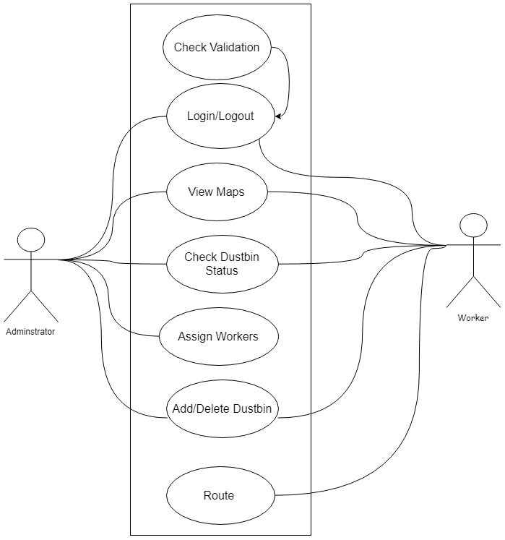

*Fig(4): UseCase diagram*

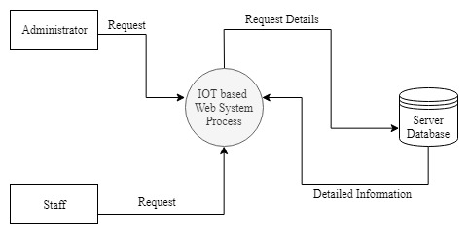

*Fig(5): Level-0-DFD*

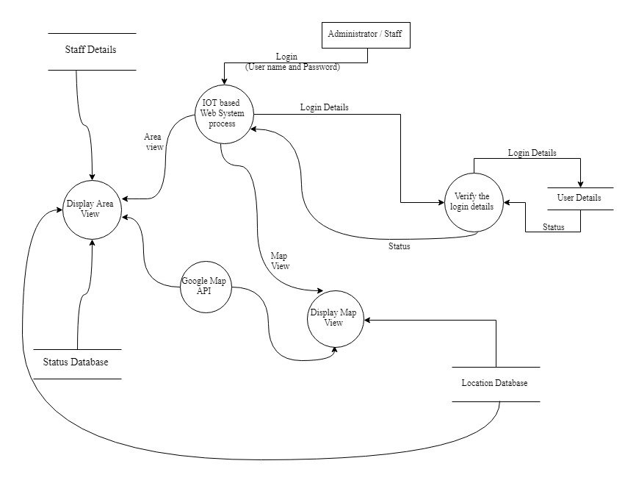

*Fig(6): Level-1-DFD*

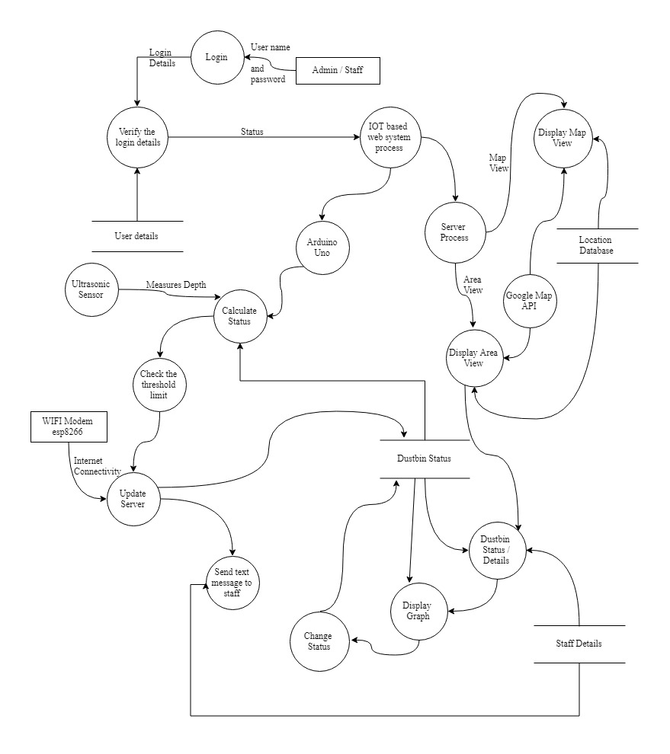

*Fig(7): Level-2-DFD*

# Proposed Output

After completion of the project it gives the full featured web application which help to manage solid waste and also help to monitor the waste level in the city and also help to track the working efficiency of the employer.

# Project Task and Time Schedule

|  |  |  |  |  |  |  |  |  |
| --- | --- | --- | --- | --- | --- | --- | --- | --- |
| **Week**  **Work** | **1st** | **2nd** | **3rd** | **4th** | **5th** | **6th** | **7th** | **8th** |
| Title Selection  & Literature  Review |  |  |  |  |  |  |  |  |
| Component  Collection |  |  |  |  |  |  |  |  |
| Problem  Discussion/Template Designing |  |  |  |  |  |  |  |  |
| Circuit Design, Connecting & Backend |  |  |  |  |  |  |  |  |
| Testing and debugging |  |  |  |  |  |  |  |  |
| Finalizing &  Documentation |  |  |  |  |  |  |  |  |

*Fig(8): Gantt chart*

# Bibliography

|  |  |
| --- | --- |
| [1] | Margaret Rouse, "IOT Agenda," [Online]. Available: https://internetofthingsagenda.techtarget.com/definition/drone. |
| [2] | From Wikipedia, "Wikipedia,," [Online]. Available: https://en.wikipedia.org/wiki/Gimbal. |
| [3] | T. E. RICKS, "FP," [Online]. Available: https://foreignpolicy.com/2015/12/10/5-big-problems-with-the-drone-programs/. |
| [4] | D. D., "Prezi," [Online]. Available: https://prezi.com/w0ymgdksss6o/problem-statement/. |
| [5] | M. LaFay, "Dummies," [Online]. Available: https://www.dummies.com/consumer-electronics/drones/popular-uses-for-drones/. |
| [6] | BBC, "Academy," [Online]. Available: https://www.bbc.co.uk/academy/en/articles/art20151214151812855. |
| [7] | S. A. HASSAN. [Online]. Available: http://docs.neu.edu.tr/library/6365457473.pdf. |
| [8] | :. A. P.V.. [Online]. Available: http://www.kscst.iisc.ernet.in/spp/40_series/SPP40S/01_Seminar%20Projects/053_40S_BE_2142.pdf. |
| [9] | Sneha Patil. [Online]. Available: http://ijarcsse.com/Before_August_2017/docs/papers/Volume_7/4_April2017/V7I4-0245.pdf. |
| [10] | A. Siddharth. [Online]. Available: https://www.geeksforgeeks.org/project-idea-smart-waste-management-systems/. |
| [11] | "draw.io," [Online]. Available: https://www.edrawsoft.com/edraw-max.php?gclid=Cj0KCQjwkK_qBRD8ARIsAOteukBOwtNydDtPp_wthLOGKvQiAi48doDvPz4VFle1BMpsbyvNgrJIKSIaAsxNEALw_wcB. |